Description | My friend stole my perfect spongebob popsicle I just opened up and won’t give it back until I tell him a secret phrase. He locked it in this program and I’m dumb so I can’t get it.
Files | challenge.exe
Hint(s) | None
Walkthrough | Running the exe, all you get is an input for the flag  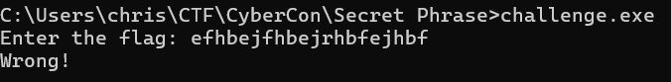  I am going to put challenge.exe into Ghidra  Looking around you see these three interesting functions:  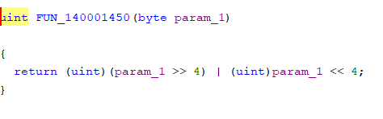  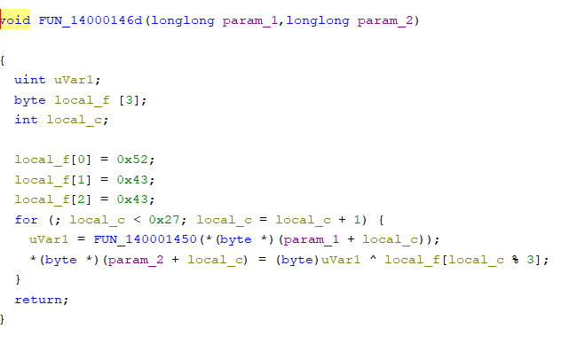  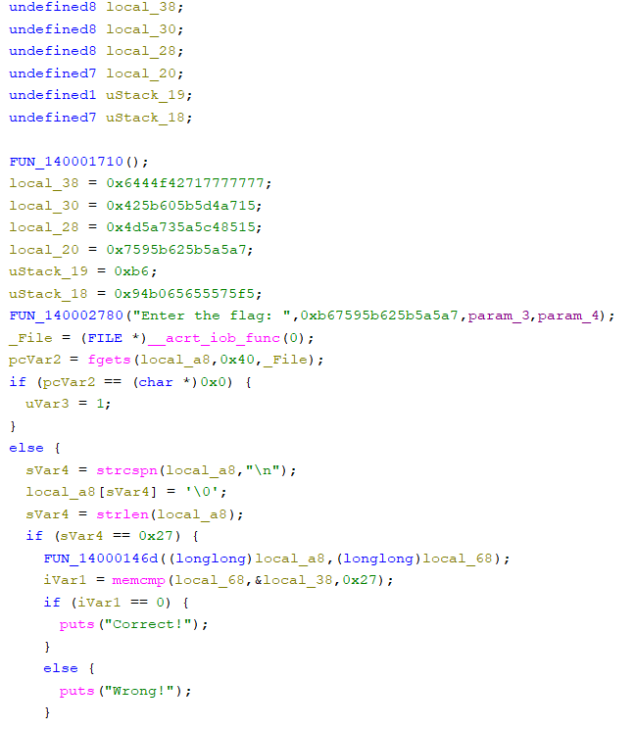  That chunk of data in the middle of the third function is what the input is compared against.  0x77, 0x77, 0x77, 0x17, 0x27, 0xf4, 0x44, 0x64, 0x15, 0xa7, 0xd4, 0xb5, 0x05, 0xb6, 0x25, 0x04, 0x15, 0x85, 0xc4, 0xa5, 0x35, 0xa7, 0xd5, 0x04, 0xa7, 0xa5, 0xb5, 0x25, 0xb6, 0x95, 0x75, 0xb6, 0xf5, 0x75, 0x55, 0x65, 0x65, 0xb0, 0x94  However, the input has some sort of manipulation done on it and then it is compared.  Looking at the functions used on the input, the first function is determined to be a nibble swap. The second one goes through an array (the input) and swaps the nibbles of each character and xor’s them with a rotating key. The third function is the main method. Here, the input is taken and encrypted, where it is then compared against the cipher text. All we need to do now is decrypt the cipher using the reverse of the steps described above in the second method.  Here is a more readable version of the encryption method.  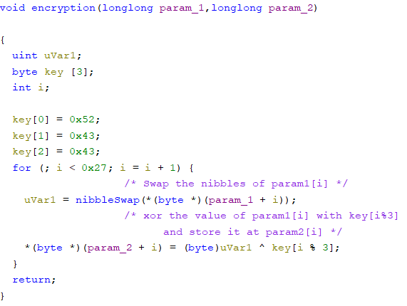  Here is an example of a solver using the cipher text recovered.  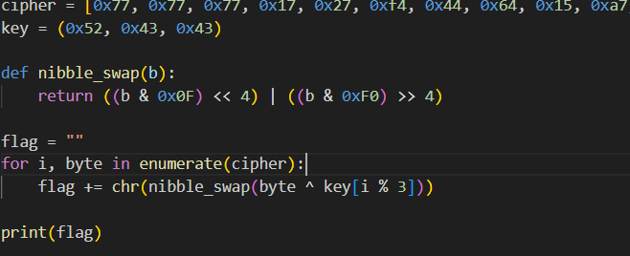  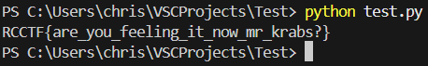
Flag | RCCTF{are_you_feeling_it_now_mr_krabs?} - Case Sensitive

